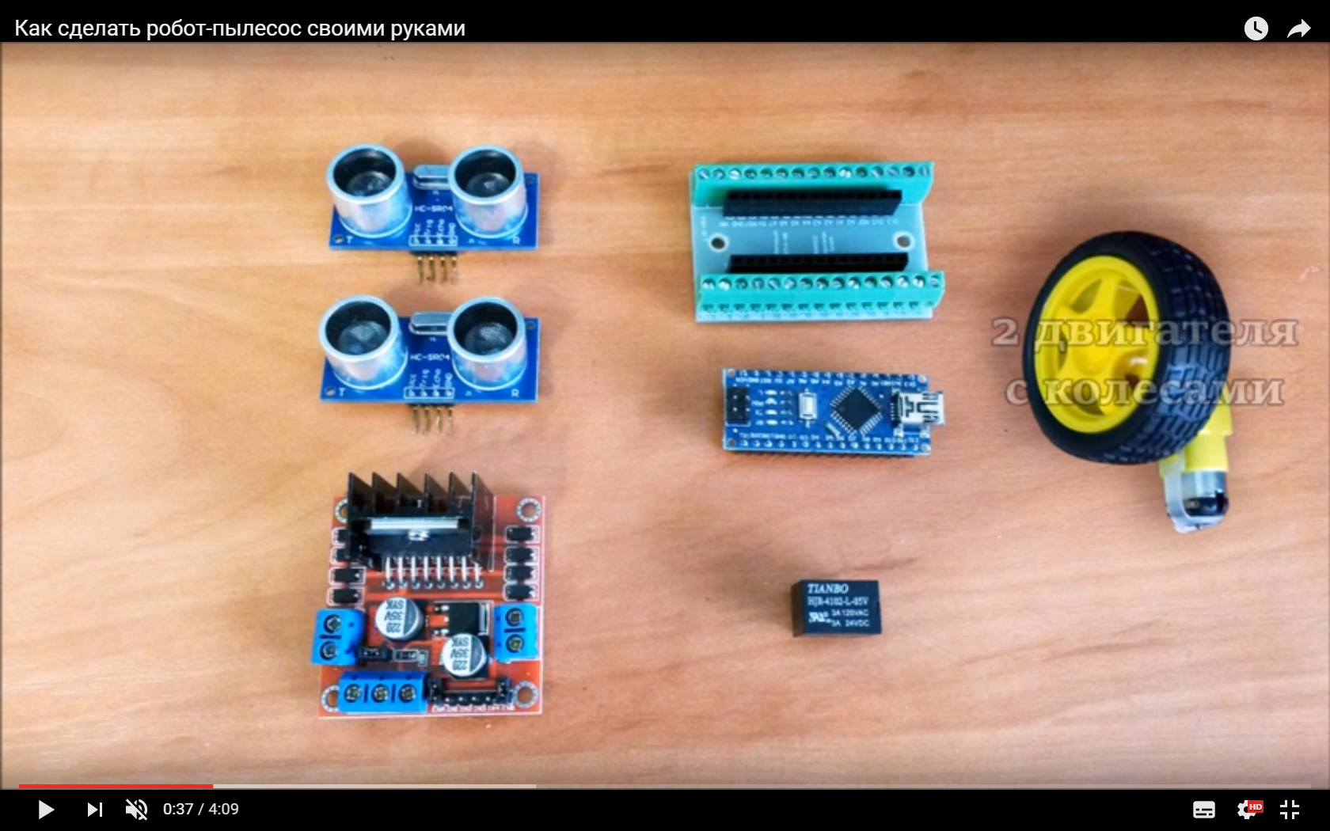

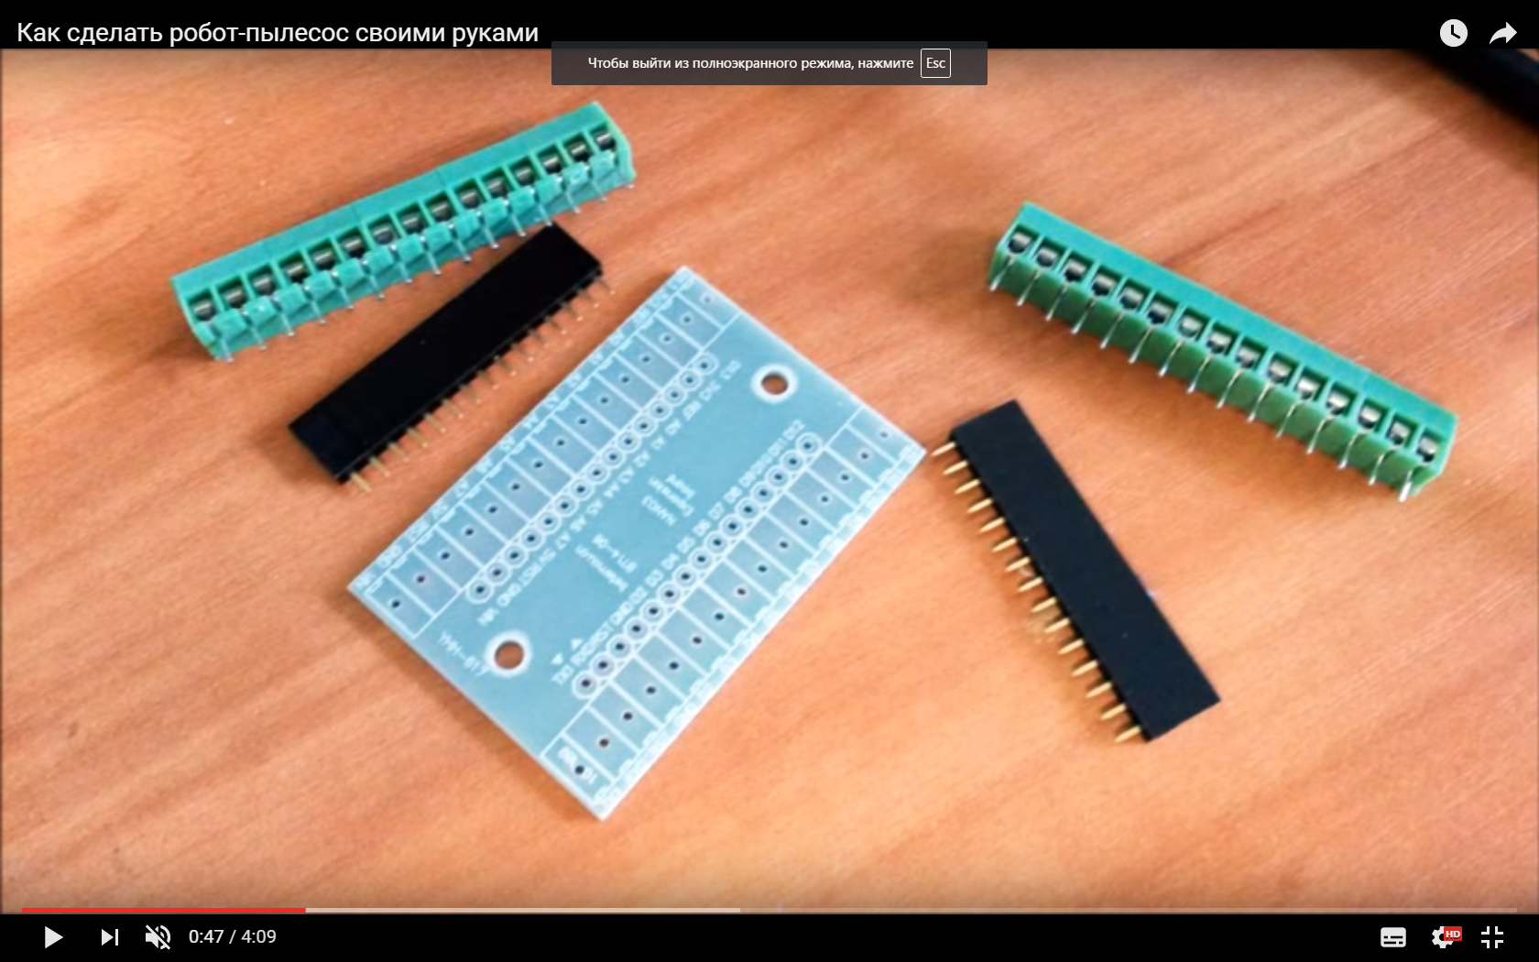

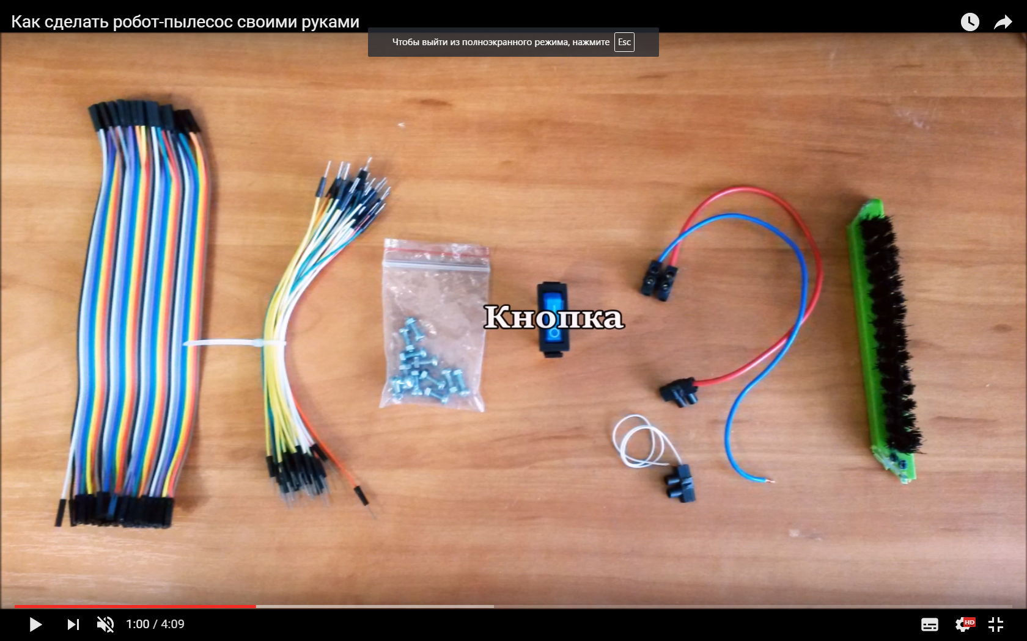

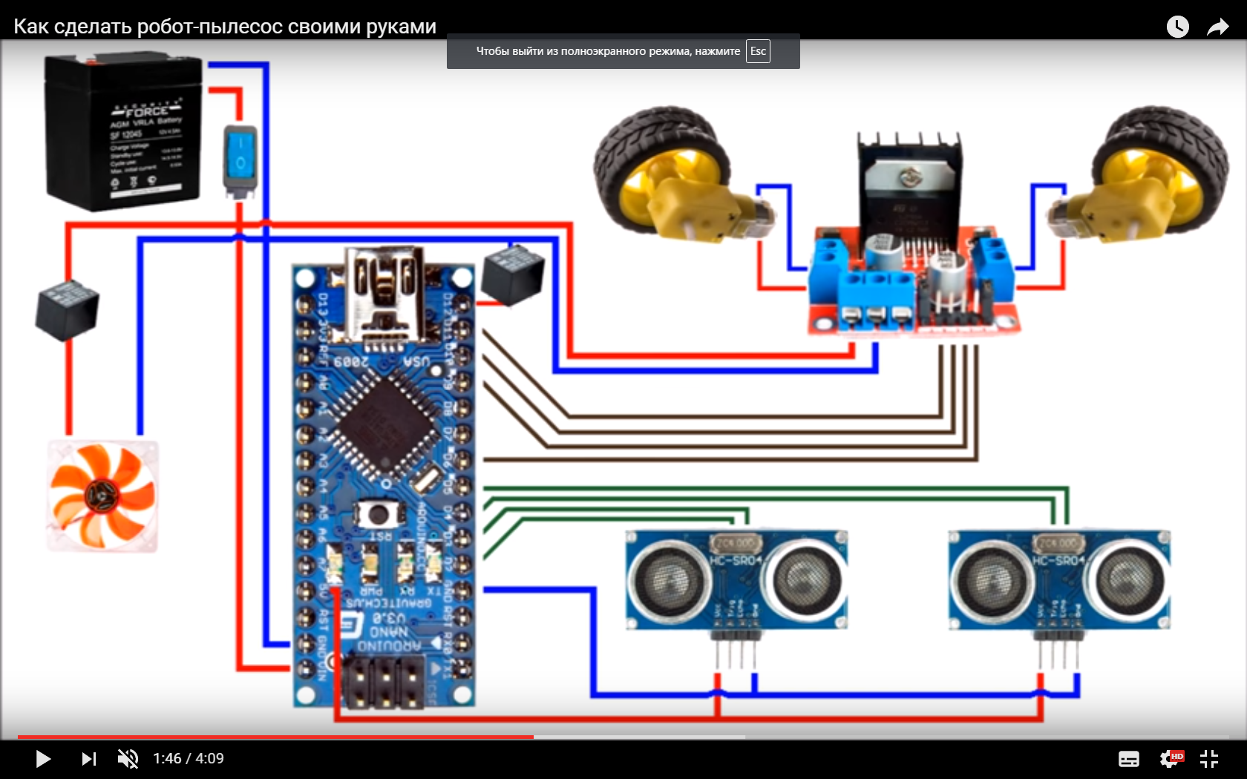

+++ Arduino NANO

+++ Shield Arduino

+++ Rangefinder hc-SRF05

+++ Driver L298N

+++ 2 Motors

+++ Castor wheel

+++ Screws

Recharge battery

Plastic boxes

+++ Wires female to female

+++ Wires male to male

+++ Button

Relay 12-24V